Hairdo How-To
The Ballet Bun
Ballet’s classic hairstyle has come to define the dancer herself: “bunhead” is dancers’ own affectionate term for ballerinas and ballet students. Meticulous grooming is part of ballet; dancers quite literally keep every hair in place. You rarely see a really good dancer with sloppy hair, and good schools never allow it. Functional, sleek, disciplined, and beautiful, the ballet bun tops off your elegant line and hold hair away from your face.
The high ballet bun and the low chignon are basic styles, easily mastered, and with practice you can even pull off the more difficult French twist in a matter of minutes. Each can be adorned in countless ways – simply for class, or elaborately with flowers, jewels, a tiara, or a special headpiece for performance.
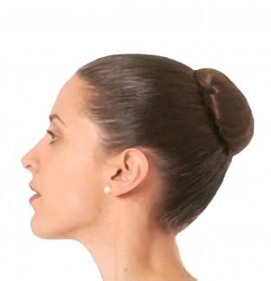
You need a brush or comb, large, sturdy 2- to 3-inch hair pins, bobby pins, and a fine hair net that matches your hair color. You also need elastic hair bands; the fabric ones are best. Never use rubber bands or elastics with metal parts – they can break your hair. It can be helpful to moisten hair using a spray bottle or tame it with an anti-frizz styling gel before you start. For performances you may need hairspray for the finishing touch.

High Ballet Bun
1. Gather hair up from your jawline to the top part of the back of your head. Use an elastic band to make a tight ponytail.
2. Twist the ponytail itself and then coil it around the elastic band making at least one complete circle; tuck the end of the ponytail under the bun and hold everything in place with your hand.
3. Use large hair pins around the bun to secure it to the rest of your hair. Use only as many as you need; three or four are usually enough. Flying hairpins are dangerous in class or on stage, so be sure your bun is fastened firmly and pins pose no threat to fellow dancers. Dancers have actually been fined for dropping hairpins in performance.
4. Place the hair net around the bun, wrapping it as many times as necessary to secure it completely. If the bun sticks up too high, flatten it with your hand and pin it down again so that the bun top is closer to your head and forms a smoother line. Use bobby pins to tidy any wisps.
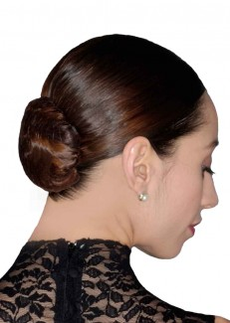
Chignon
The chignon, or low bun, which is positioned at the nape of your neck, is the hairstyle of many a Giselle; it is also a great option if your hair is shorter than shoulder length.
Make a low ponytail then form the chignon as described for the high bun.
Dancers with very short hair may use a hairpiece bun for a particular role or performance; otherwise, securing hair away from your face with pins or inconspicuous barrettes should do the trick for class.

